**Input file:**

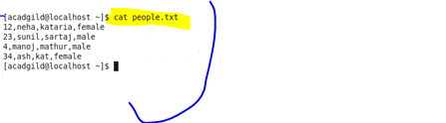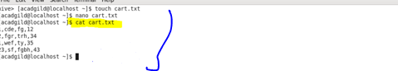

**Create table and load data :**

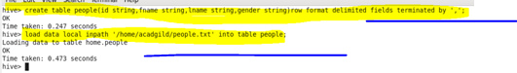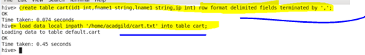

**Create view :**

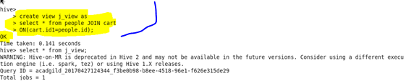

**Output:**

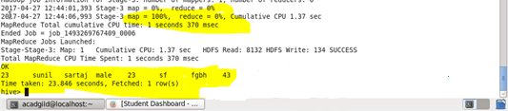

**Query :**

